

Table of Contents

Executive Summary 3

INDEX.HTML CODING PAGE 4

INDEX.HTML USER INTERFACE 5

ABOUT.HTML (CODING PAGE) 6

ABOUT.HTML USER INTERFACE 7

PHOTO.HTML(Coding Page) 8

PHOTO.HTML USER INTERFACE 9

L3TUTOREGISTRATION.PHP(CODING PAGE) 10

L3TUTOREGISTRATION.PHP USER INTERFACE 12

LOGIN.HTML USER INTERFACE 13

WEB DESIGN FLOW CHART 14

WEB DATABASE 15

INSERT DATA FOR MEMBER 16

VIEW DATA FOR MEMBER 17

ADMIN USER TABLE 17

DROP TABLE 18

EXPORT DATABASE 18

IMPORT DATABASE 19

IMPORT DATABASE 19

ADMIN LOGIN WEBPAGE 20

# 

# Executive Summary

In this assignment, it’s all about attracting more students across a nation to come and join the TMC Tennis Club through launching our website. The name of the tennis club is “TMC Tennis Club” and influencing not only to the students but also to the aged person and the child. The website motto is “It’s for Everyone”.

The main issue discussed on this page is the TMC Tennis Club website, where any club member may enjoy sports. Every club member is welcome to use the website to engage in matches, and the main focus of the website is club member registration. On this website, PHP Validation is used to check for mistakes, and members are expected to enter accurate information about themselves. Members may have fun with other members and learn new things by browsing the extensive match information on our website. This website is implemented on XAMPP and Visual studio code.

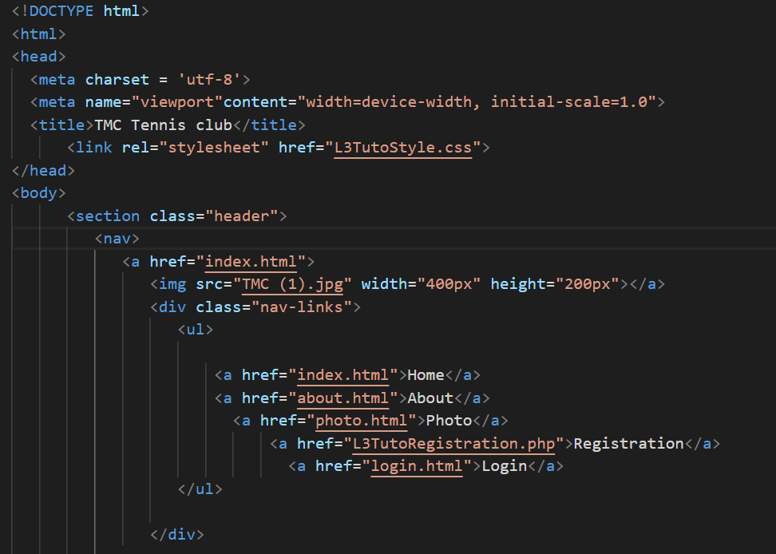

# INDEX.HTML CODING PAGE

Index.html coding…

This is the “index.html” in which “index.html” is named as “Home” and also declared with the class i.e., header in CSS file to operate in “index.html” to outcome the result which will show later. While, not forgetting the other link by using anchors to connect another webpage i.e., (about.html, photo.html, L3TutoRegistration.php, Login.html) for the user interface to connect with the website visitor. The image source is also defined with the proper width and the height to display in the user interface. Unordered List is also used to present the navigation bar at the right side with help of different division classes. The External Cascading Style Sheet of classes should be implemented in the “index.html”. Then declare CSS navigation class in html. Note: The implementation of navigation bar will be same in the rest of four webpages user interface.

# INDEX.HTML USER INTERFACE

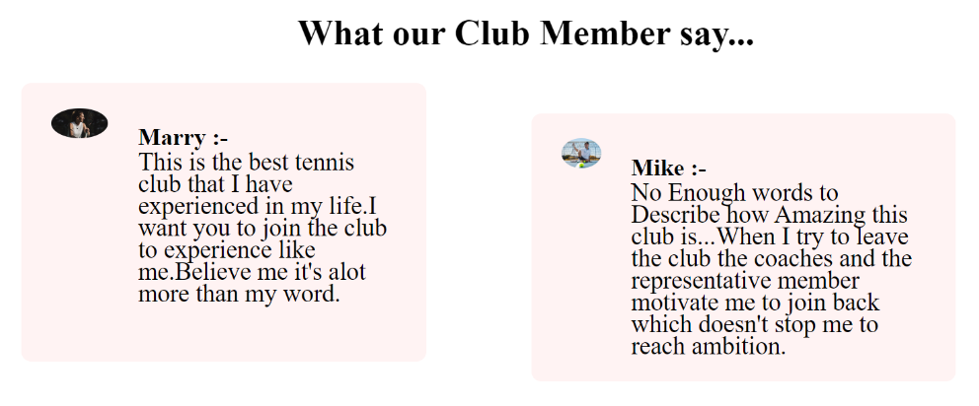

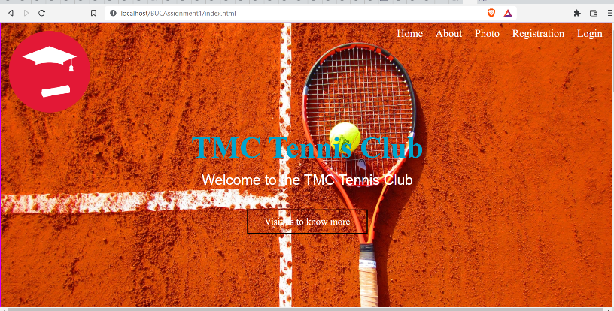

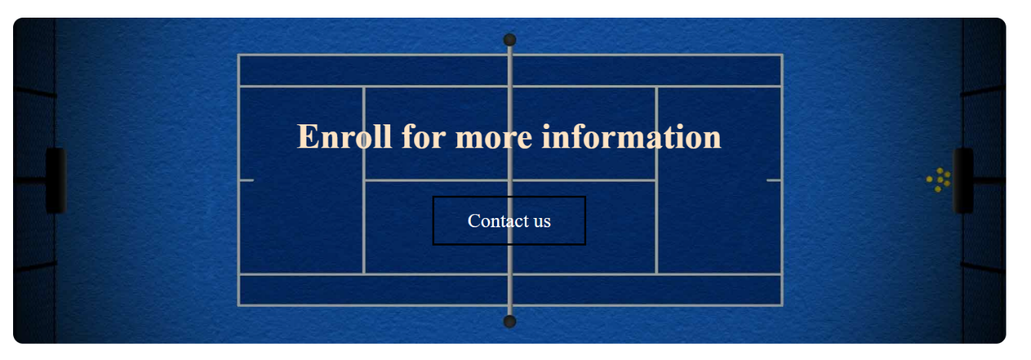

This is the welcome homepage website for the user who is interested in joining the TMC Tennis Club to play Tennis. The home page consists of navigation bar at the right side and the TMC logo to the left side. If the user clicks the “Visit us to know more” hover button It will directly reach to the (about.html) page. Another snap is the beautiful girl sitting with the tennis racket representing that the club is not only for male but for the female too. The TMC Tennis club has one of the most trained coaches across the nation to train the students. They are not only the coaches but also the Director, and the principal of this foundation. The review is also given above it. If the user clicks the hover button named “contact us” it will directly move to the (registration.html) for the new web visitor who want to join the club.

# ABOUT.HTML (CODING PAGE)

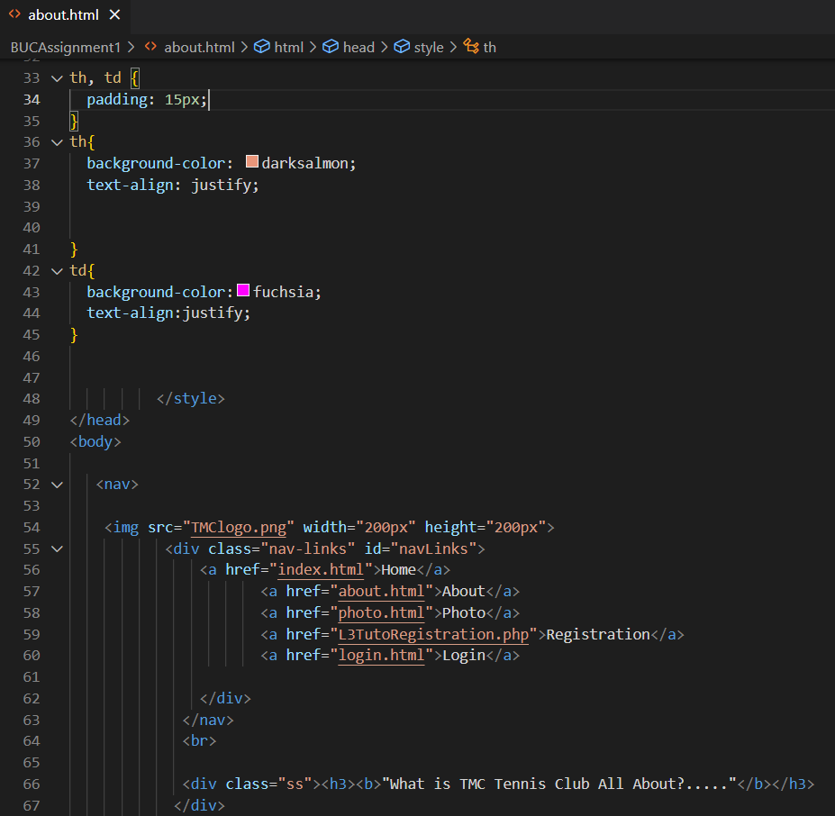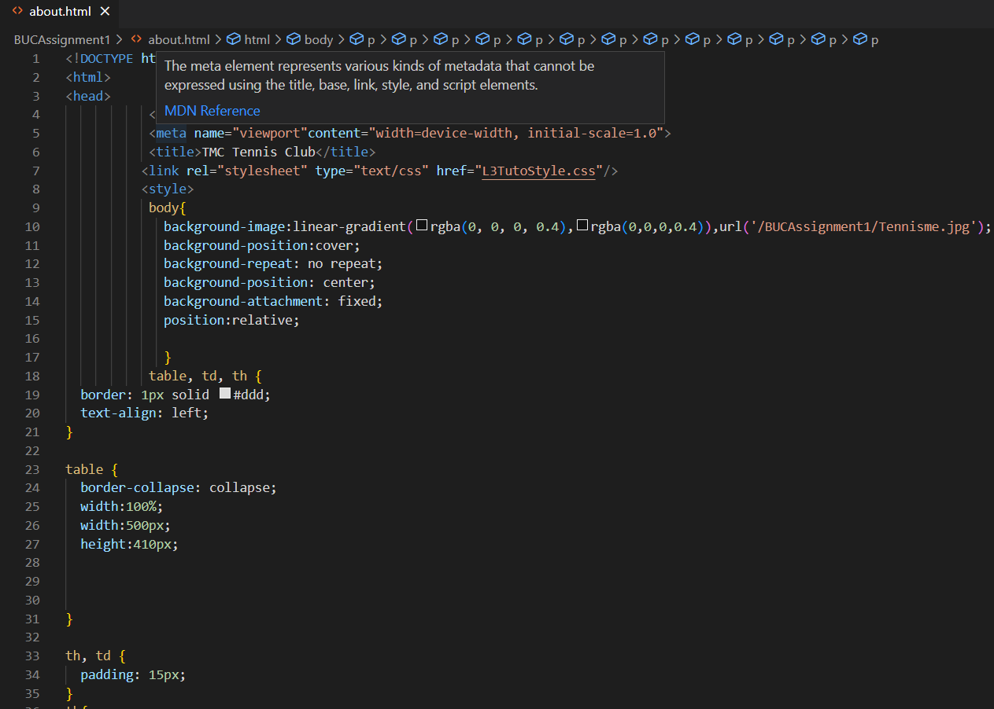

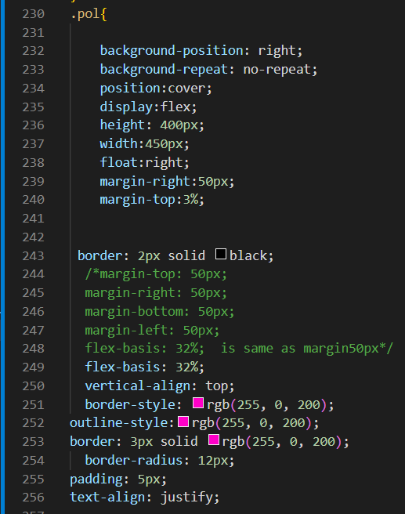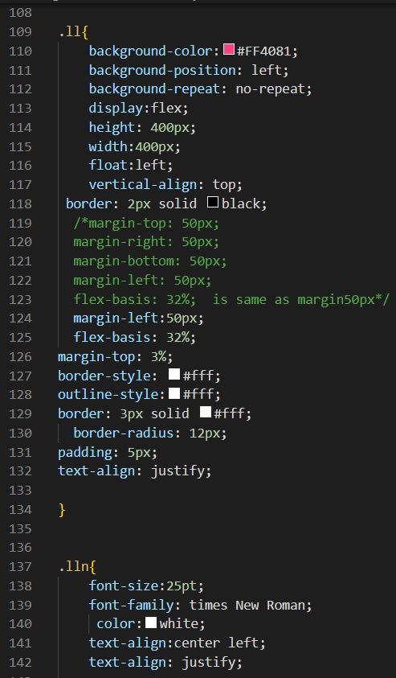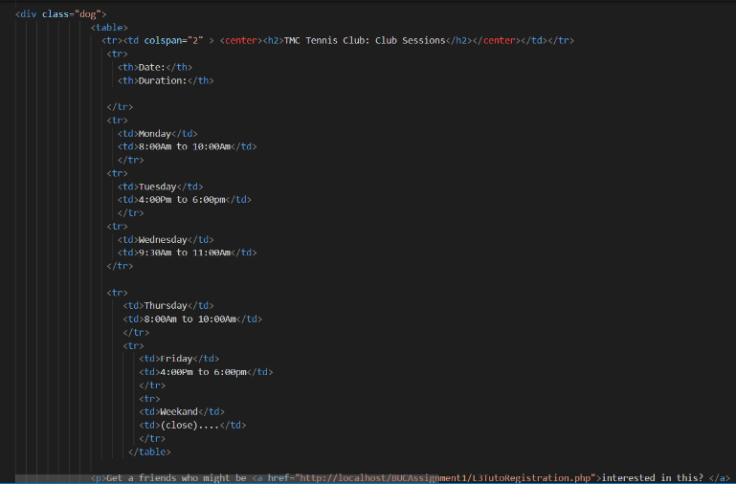

This is the html coding page and External Cascading Style Sheet which connect with each other. About.html coding page consist of internal cascading style in which it declares creating the table for the TMC Club Session. About.html is connected to all the home.html, photo.html, L3Tutoregistration.php, login.html with “href”. The L3Tutostyle.css style sheet contain the class with the different name such as pol, dog, etc., to create the division for the interface webpage.

# ABOUT.HTML USER INTERFACE

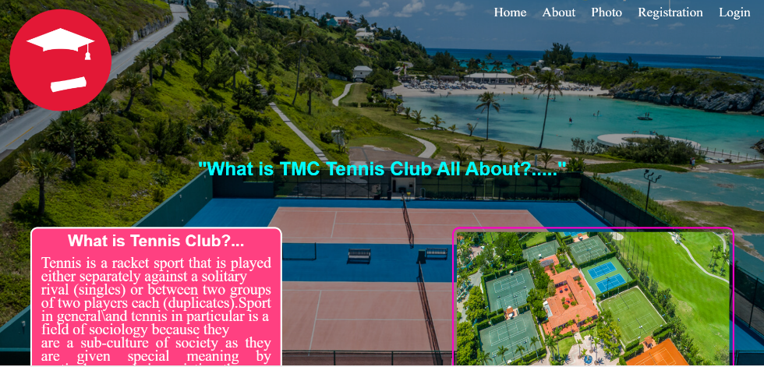

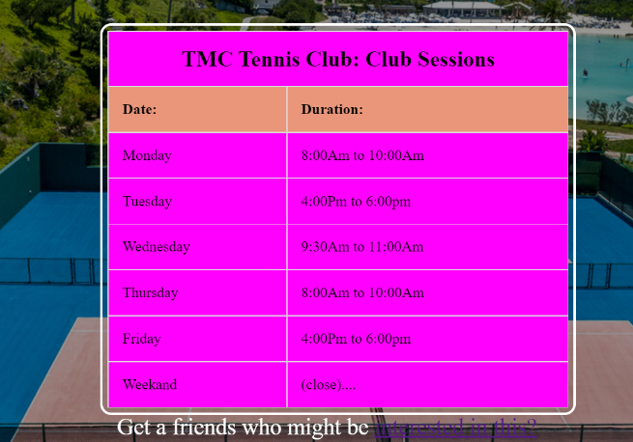

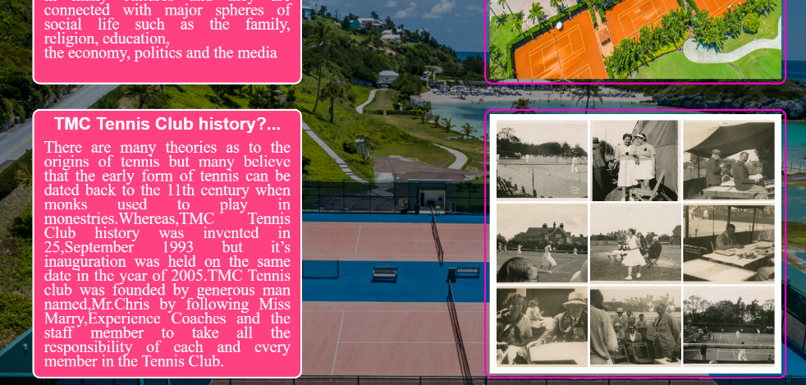

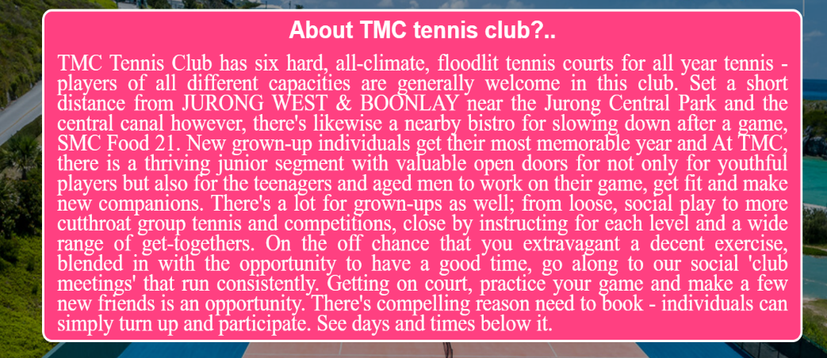

This is the user interface of about.html in which it has described:

* What is Tennis Club? (With the TMC Playground photo beside it).
* TMC Tennis Club history? (With the history photo beside it).
* About the TMC Tennis Club?
* TMC Tennis Club Session with the build table.

# PHOTO.HTML(Coding Page)

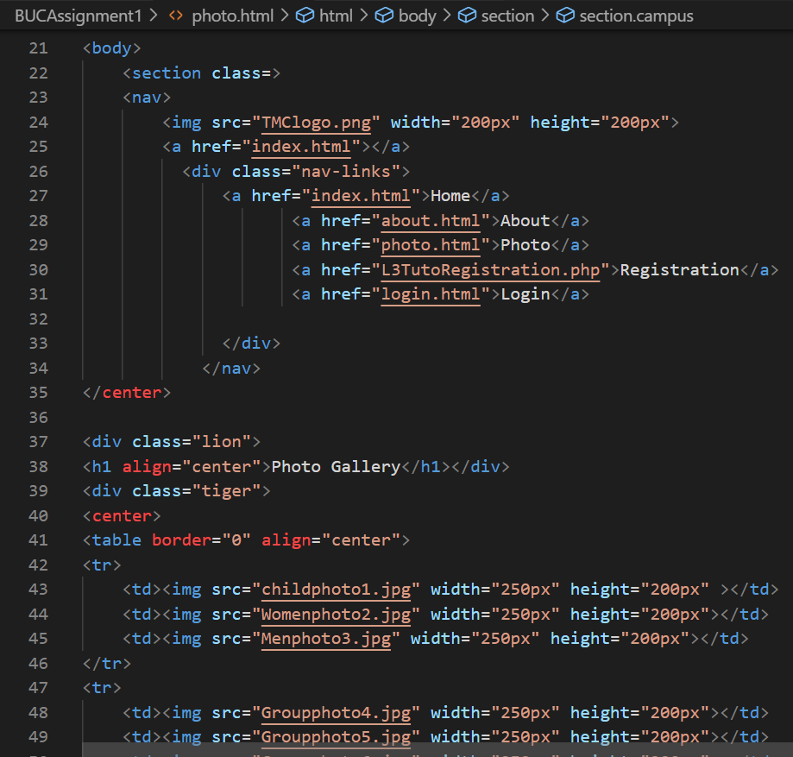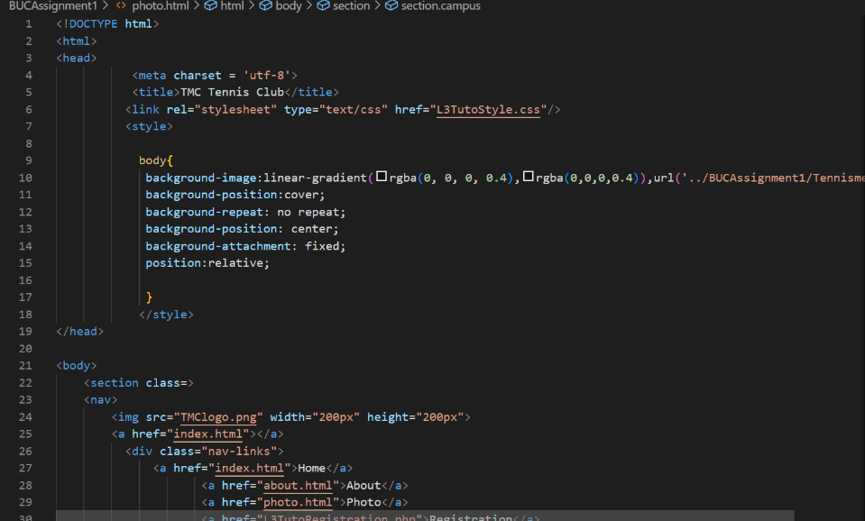

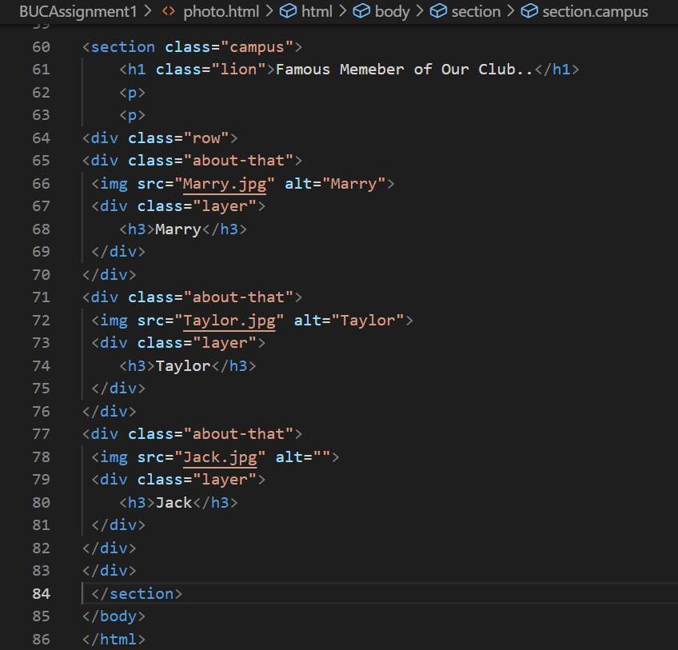

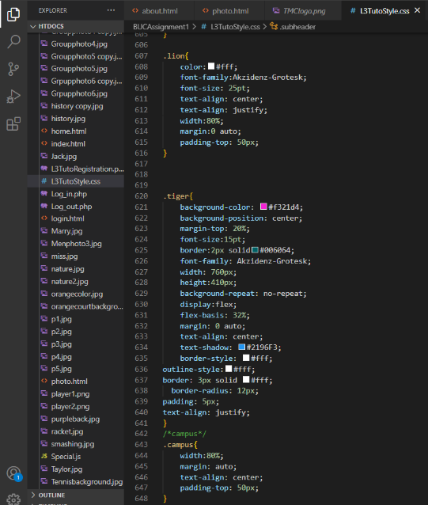

This is the html coding page and External Cascading Style Sheet which connect with each other. Photo.html consists of division classes like tiger, campus etc., which was created in L3Tutostyle.css file.

# PHOTO.HTML USER INTERFACE

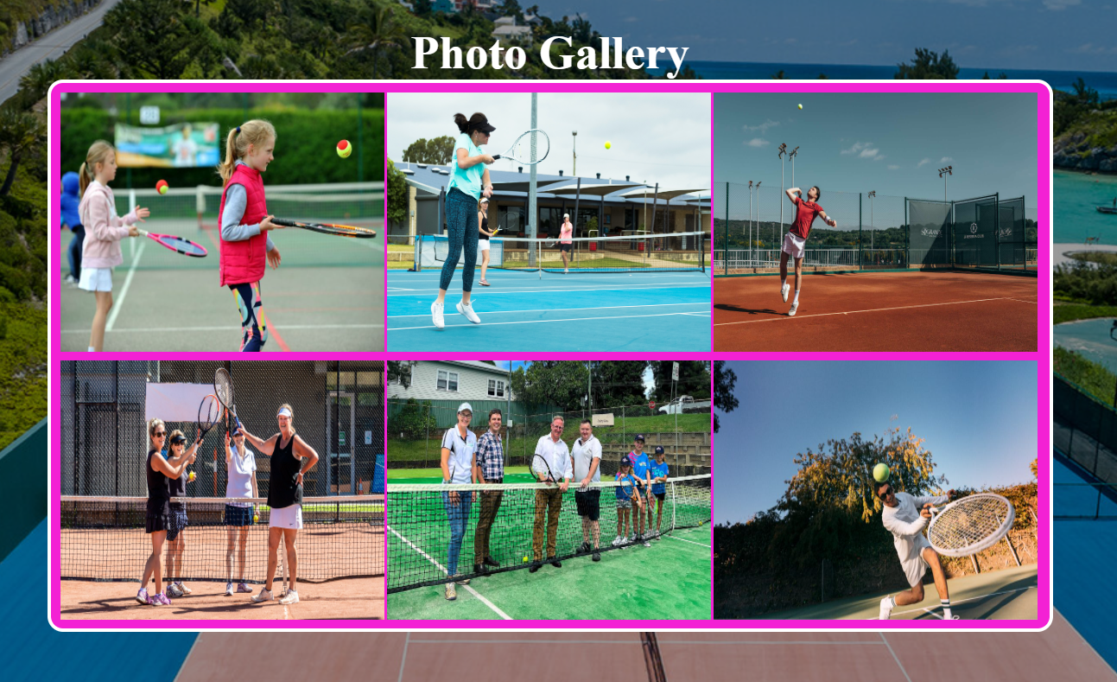

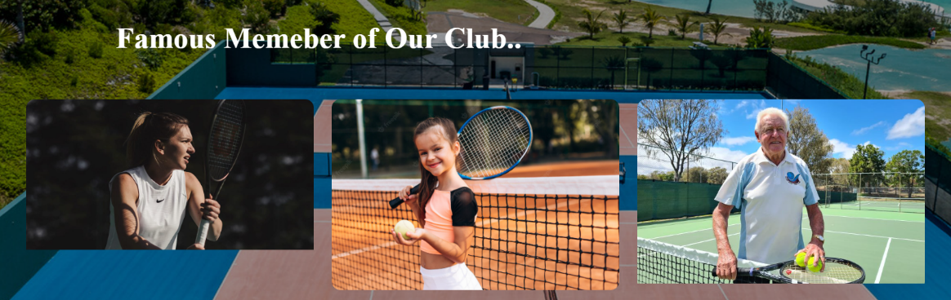

This is the snap of photo.html interface in which it has shown the photo gallery of the member includes student, children, professional player and the golden ager. The other one represents Famous Member of Our Club named Marry, Taylor and Jack who has won the tournament last year in the national selection.

# L3TUTOREGISTRATION.PHP(CODING PAGE)

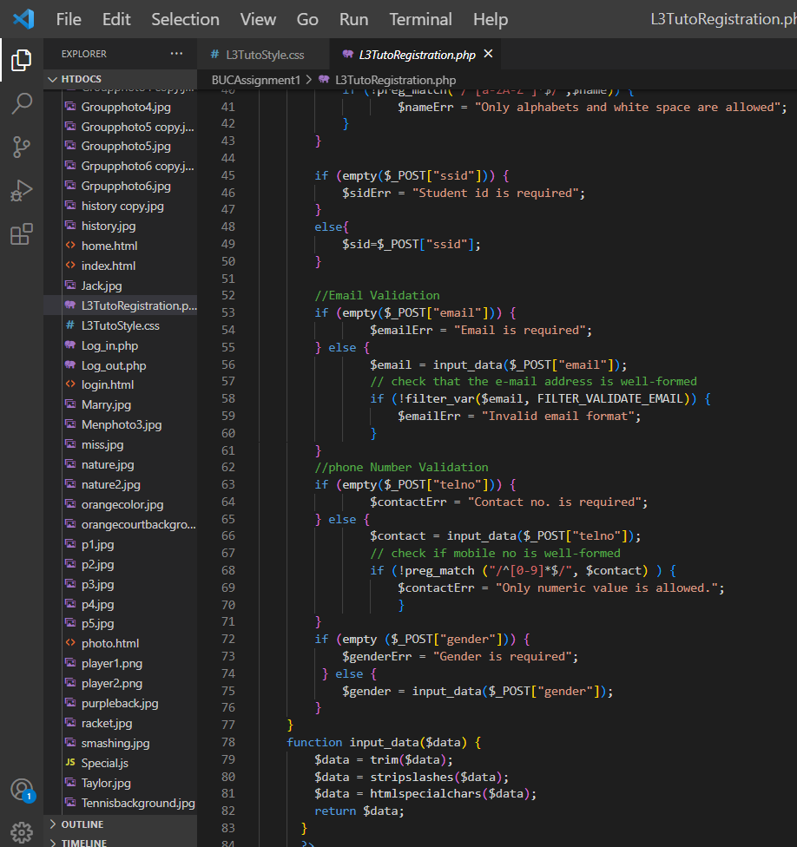

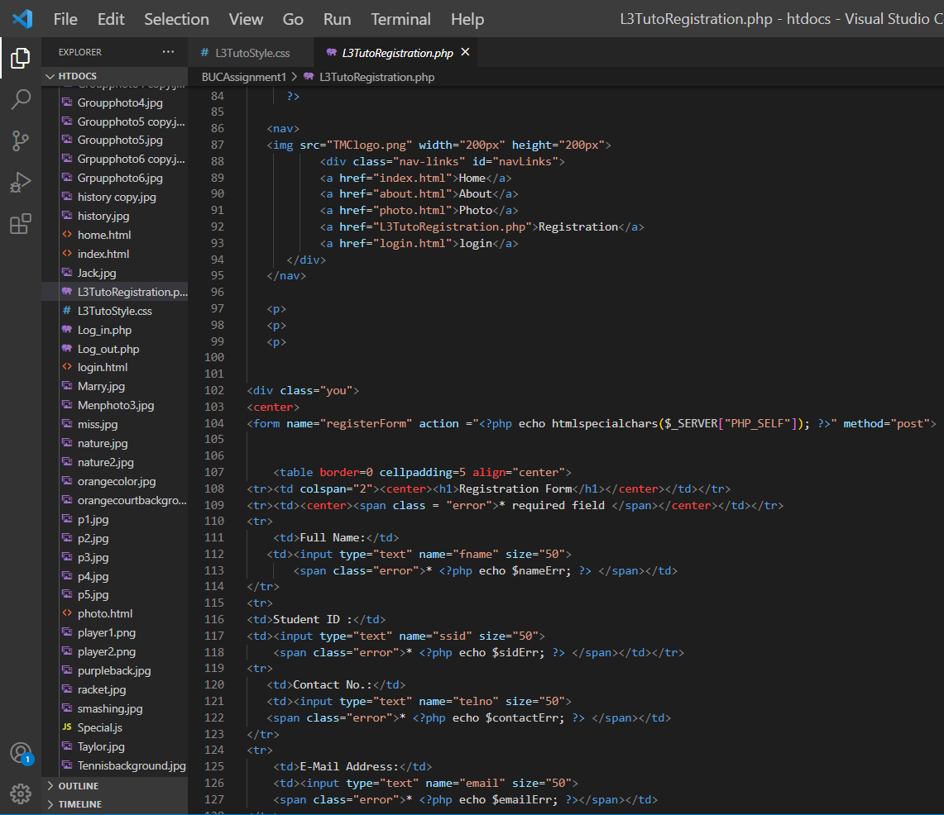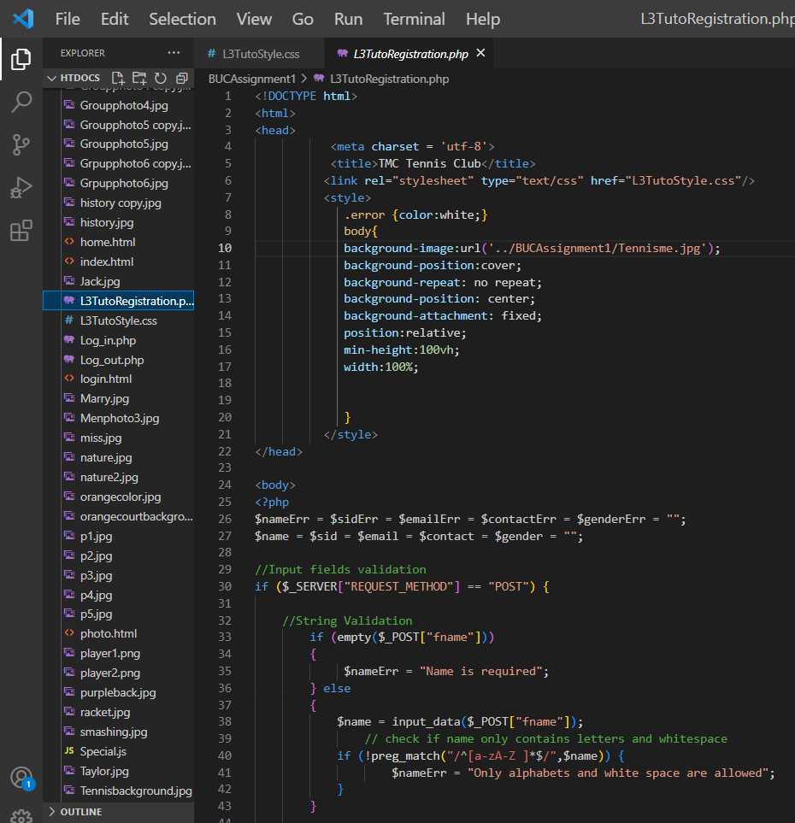

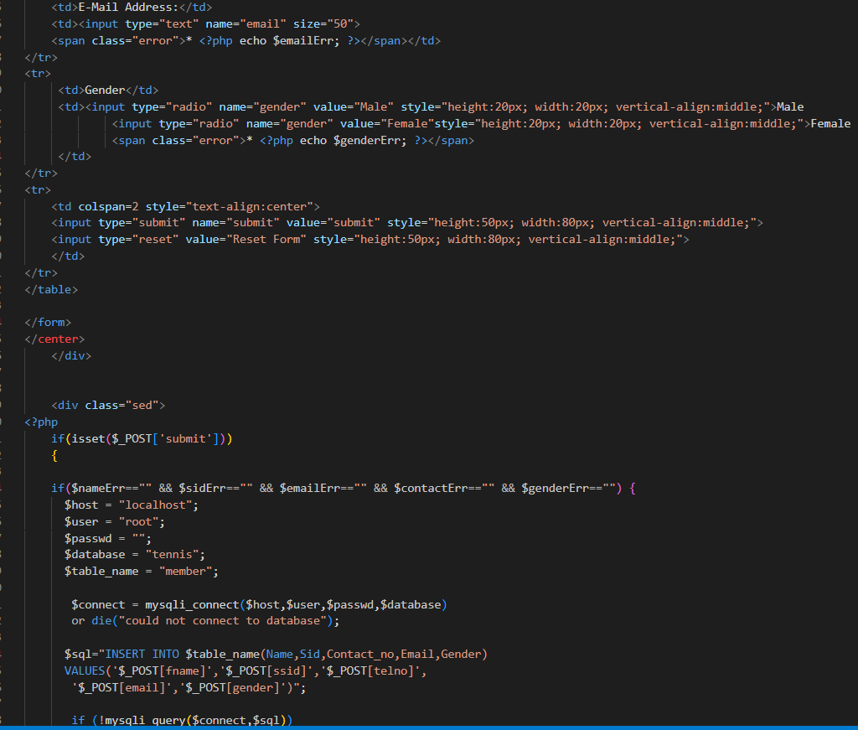

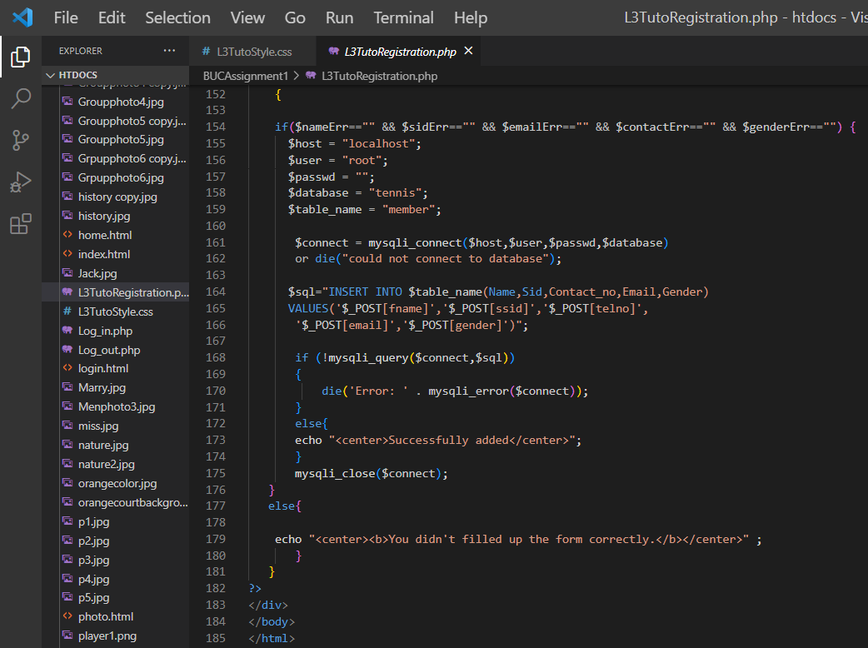

This is the coding page of L3TutoRegistration.Php by checking validation that the user has put all the details given in the registration form.

# L3TUTOREGISTRATION.PHP USER INTERFACE

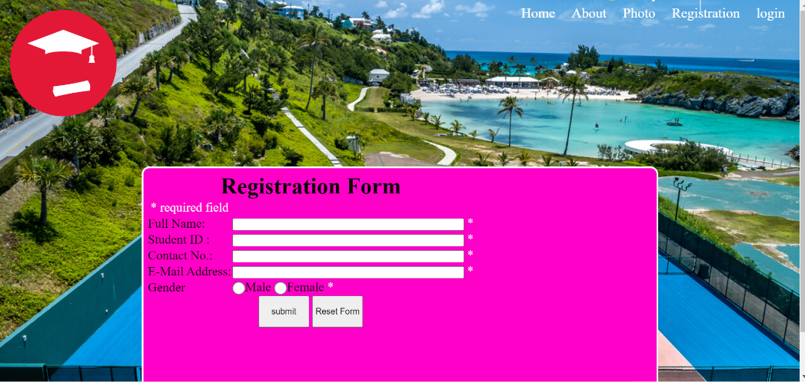This is the registration form which is created by php for its validation and the CSS for its designing.

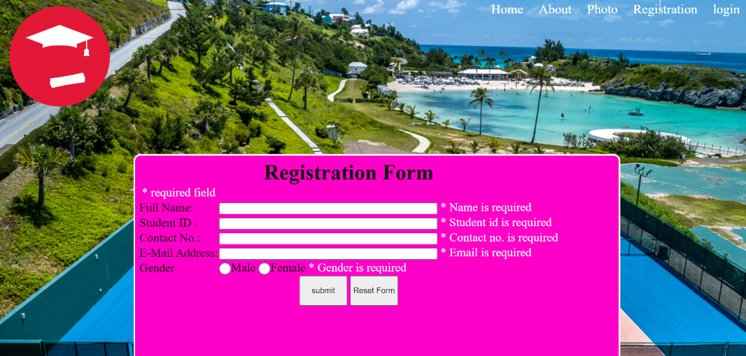

If the user clicks the “submit” button without filling or unnecessary filling data information in the form it will show validation that the information is required to fill or the filling information is not correct.

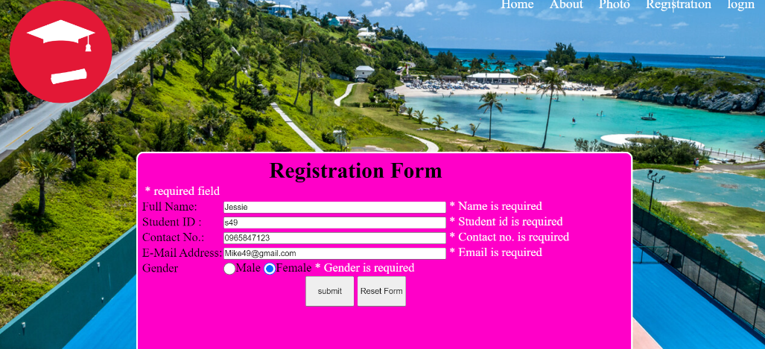

The user input Jessie in the “Full name” bar, s49 in the “Student ID”,0965847123 in the “Contact number” bar and the “[Mike49@gmail.com](mailto:Mike49@gmail.com)” in the “E-Mail Address” bar and the select the Female option in the “Gender”.

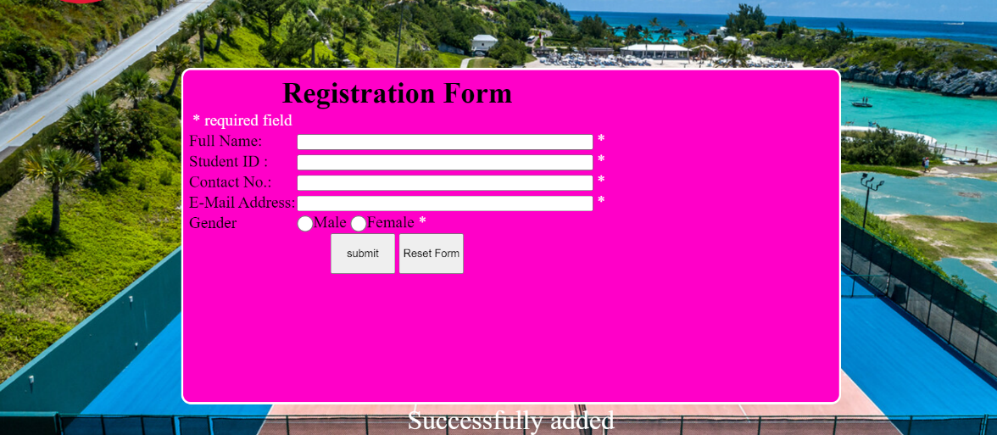After filling the correct required information data in the registration form the user click the “submit” button it shows that the data is “successfully added”.

# LOGIN.HTML USER INTERFACE

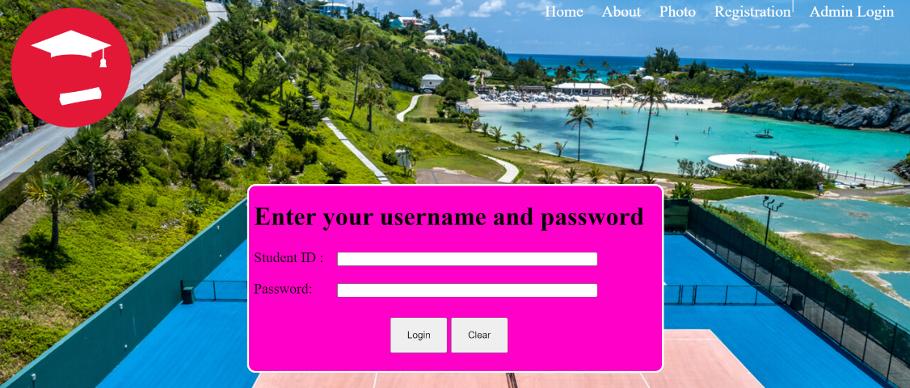

The admin login is for the one who know Student Id and Password to access to it. Basically, it is handled by the backend developer.

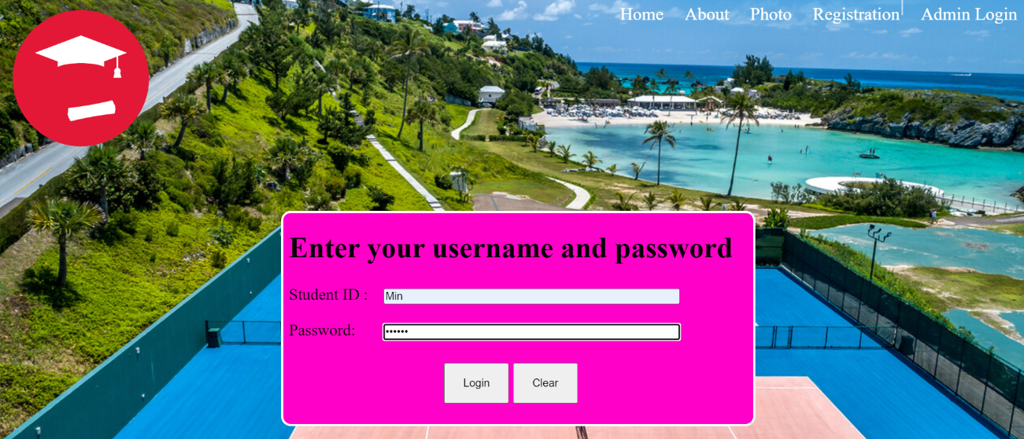



First, include a hyperlink to the CSS document inside the admin web page's header (L3tutostyle.Css). The menu button and navigation bar have to then be created. Then, to add layout writing to the main page, construct Sections and Divisions training. The shape is constructed in admin.html the use of a table, some of lists (each looked after and unordered), and several lists. The simplest person who can complete this form is the website administrator, who's additionally in rate of many other features. Admins have the subsequent manipulate features: delete, add, edit, and consider. After putting the right student Id and the password then you will connect to the backend. The user can View, Add, Edit, Delete and logout option to access.

# WEB DESIGN FLOW CHART

Home

Home

Log Out

View Data

Add New Member

About

Delete Member

Edit Member

Admin Welcome

Member Registration

Admin Login

Photo

# WEB DATABASE

User ----: Website Admin (insert, update, delete, view)

Member----: Tennis club member (registration)

**Create Database: “tennis”**

**Create table: “member”**

* Mid: Primary key, auto increment
* Create Table: member
* Mid: integer, Primary key: save

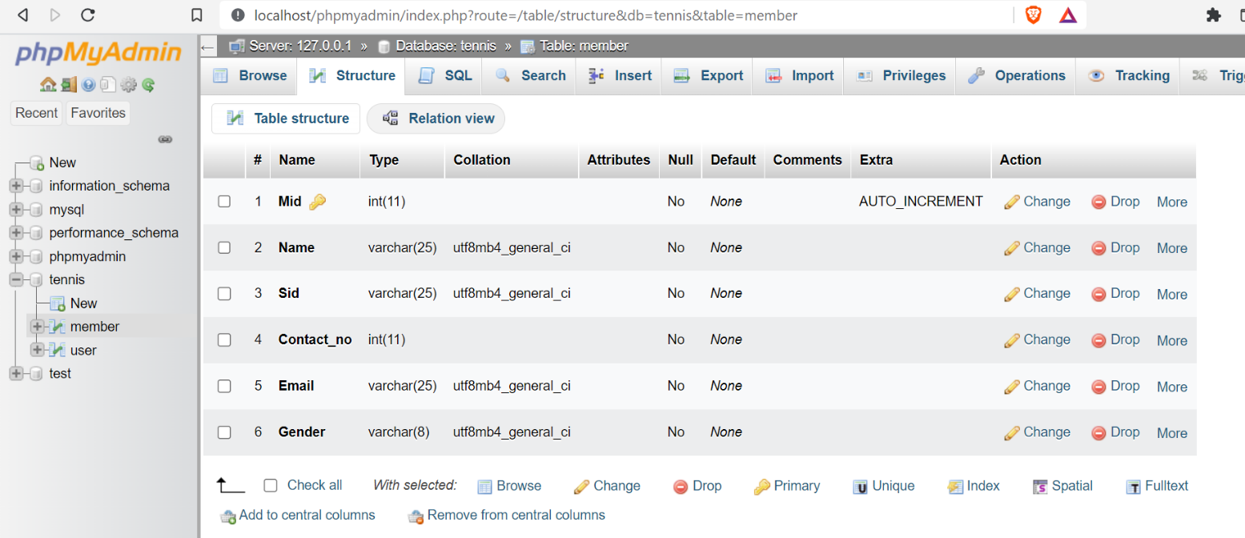

In Structure Tab, id => click change () => check A_I and Save

In Operation Tab: table option: set AUTO_INCREMENT

# INSERT DATA FOR MEMBER

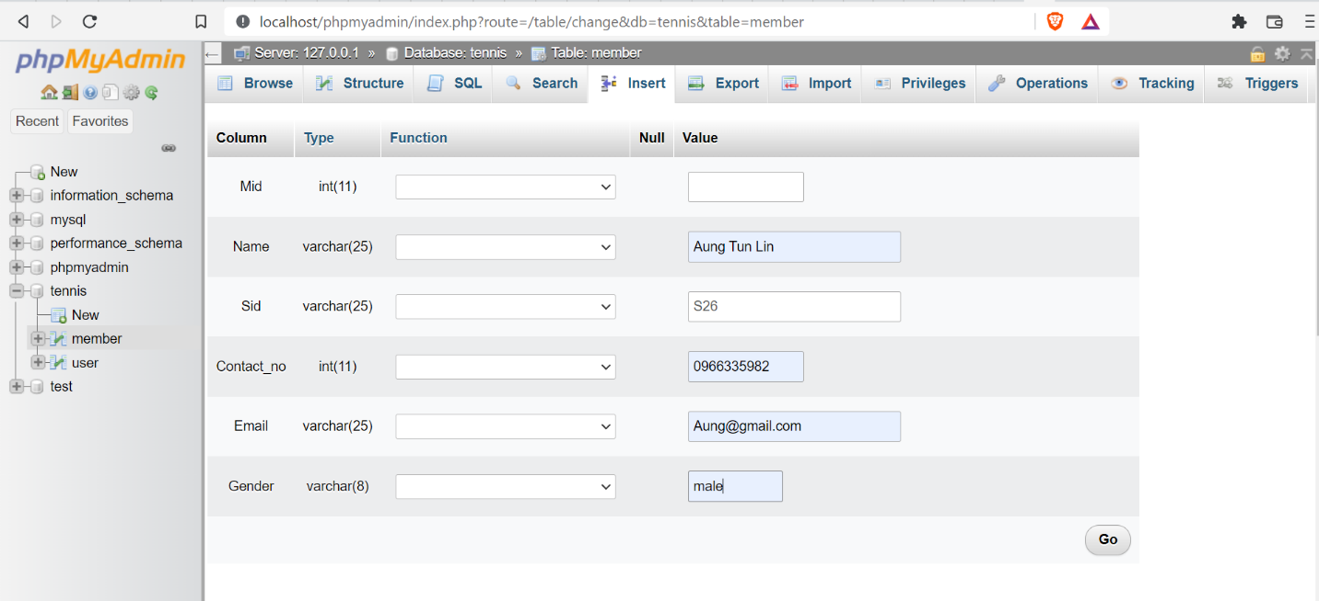

# VIEW DATA FOR MEMBER

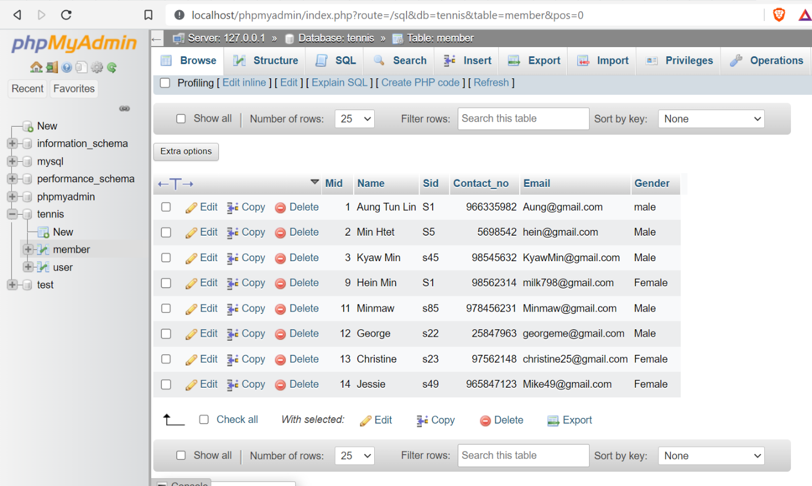

# ADMIN USER TABLE

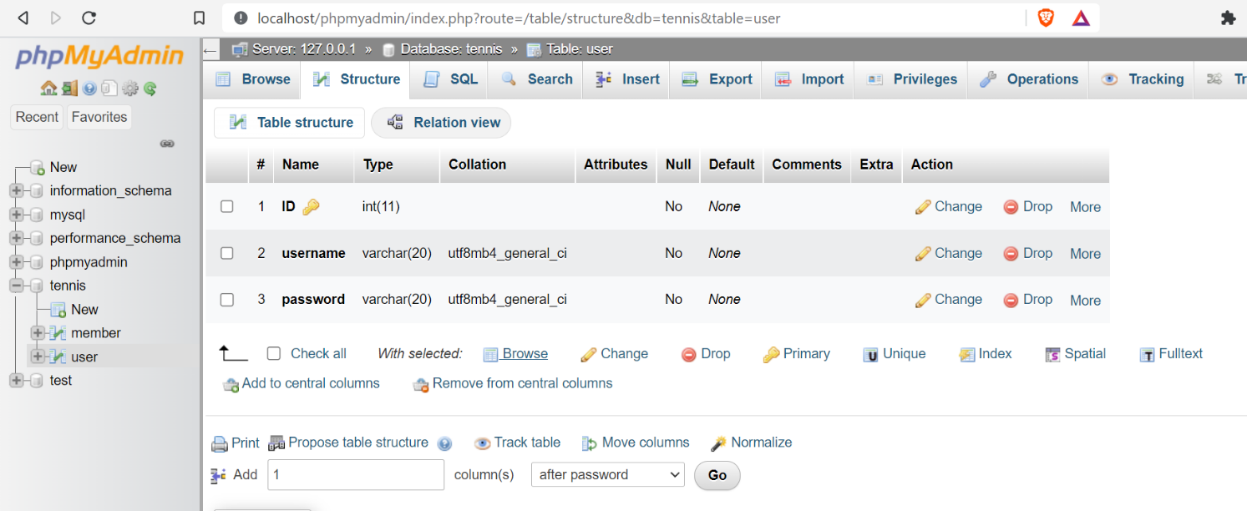

# DROP TABLE

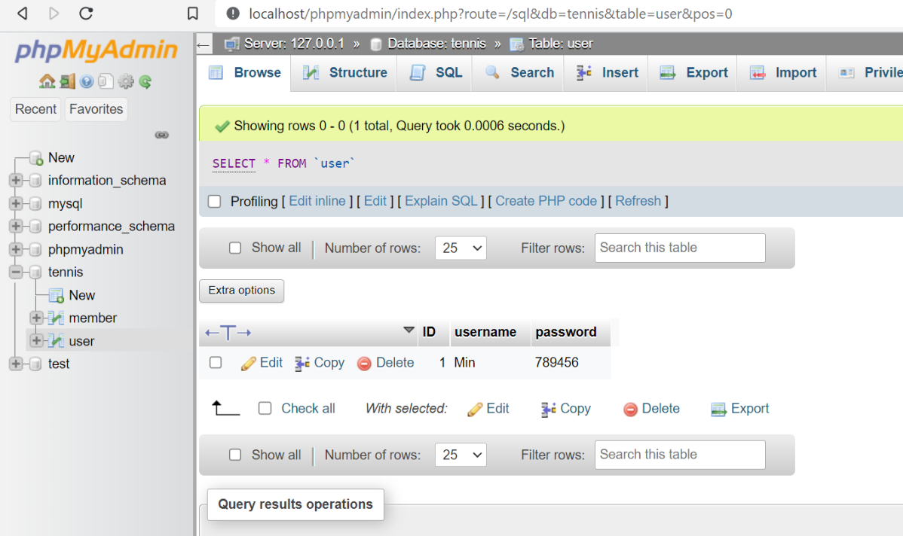

If the Administrator want to delete the table, then there is a “delete” option give it.

# EXPORT DATABASE

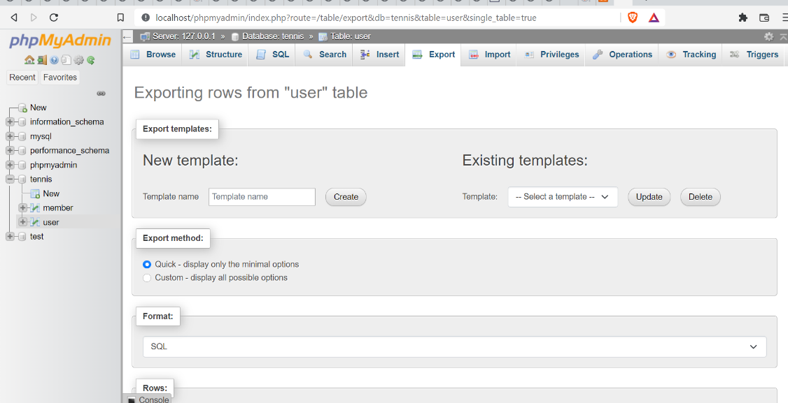

* Log in to the given phpMyAdmin application.
* Click the application database in the left navigation menu.
* Select the "Export" menu option.
* On the next page, select the "Quick" export option and the "SQL" output format.
* Press the "Go" button.

# IMPORT DATABASE

As the first step, open your database in phpMyAdmin.

Step 2: - Select Databases from the top menu.

Step 3: - Click on the database name to which you want to import data.

Step 4: Click Import.

Step 5: Choose a file and hit the Go button.

Step 6: You are now completed.

Note: if you want to change the name of the exported database you can change it.

# IMPORT DATABASE

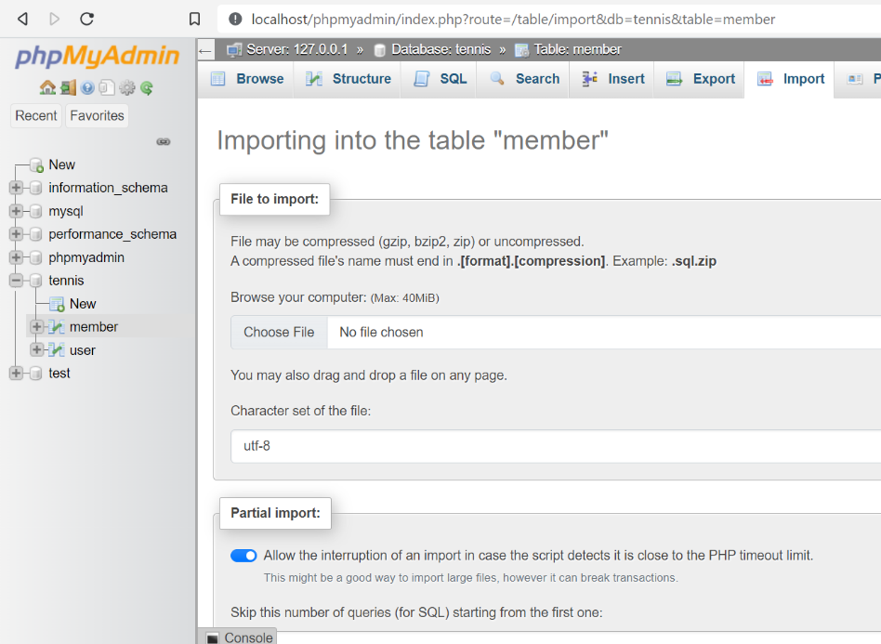

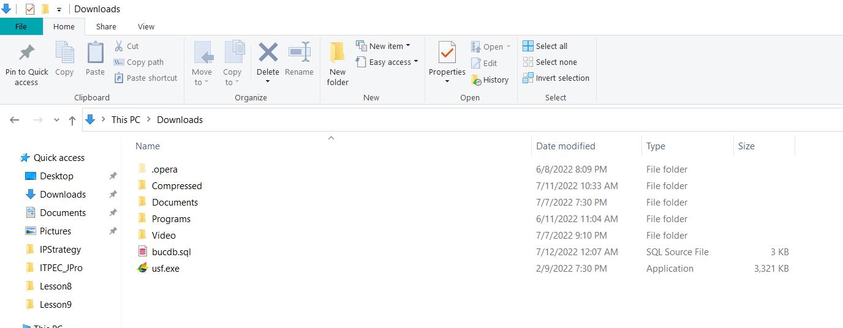

If the admin want to import file then user may chooses file shown above in the snap. The admin can import the file from the place where the admin has exported the file.

# ADMIN LOGIN WEBPAGE



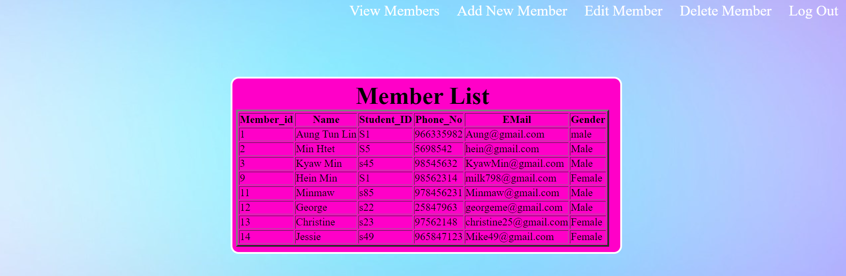After the administrator put correct name and password it will log to admin webpages. There are View Members, Add New Member, Edit Member, Delete Member and Logout at the navigation bar.

This is the view member data list in which the administrator adds the new member in the “Add New Member”.

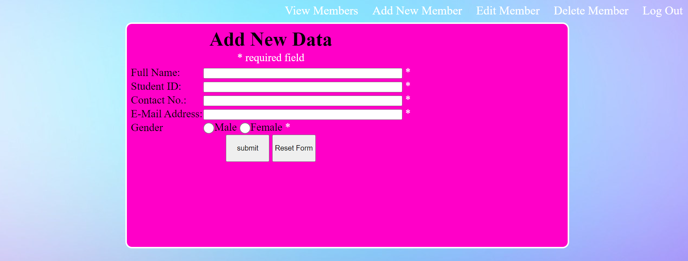

In this page the user can edit add the new information data of the user correctly in the correct place it will add to the database and the admin can also view in the “View Member” web page.

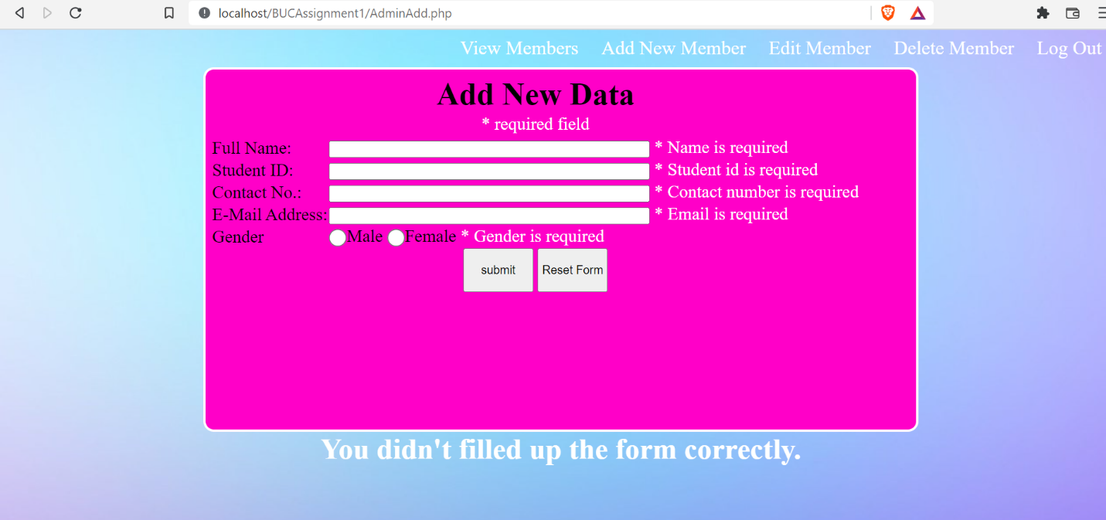

If the admin adds the data incomplete or incorrectly it will show check the validation as shown in the above snap.

This is the Edit page of database record in which admin can insert the Member ID that is already exist in the database. Admin can hit the submit button after completing form. The admin can check the edit data in database.

This is the delete page of database record in which admin can insert the Member ID that is already exist in the database. Admin can hit the submit button after completing form. The admin can check the delete data in database.



It will reach to user interface webpage after login out.

(w3school, 2022; w3school, 2022)

# References

w3school, 2022. *w3school.* [Online]   
Available at: https://www.w3schools.com/php/php_form_validation.asp  
[Accessed 27 7 2022].

w3school, 2022. *w3school.* [Online]   
Available at: https://www.w3schools.com/css/default.asp  
[Accessed 27 7 2022].